Assignment- 4

|  |  |
| --- | --- |
| AssignmentDate | 12November2022 |
| StudentName | Muthusubramanian.M,Pradesh.B,Vignesh .D,Sree prakash.M |
| IBM ID | PNT2022TMID22332 |

1. Pullanimagefromdockerhubandrunitindockerplayground:

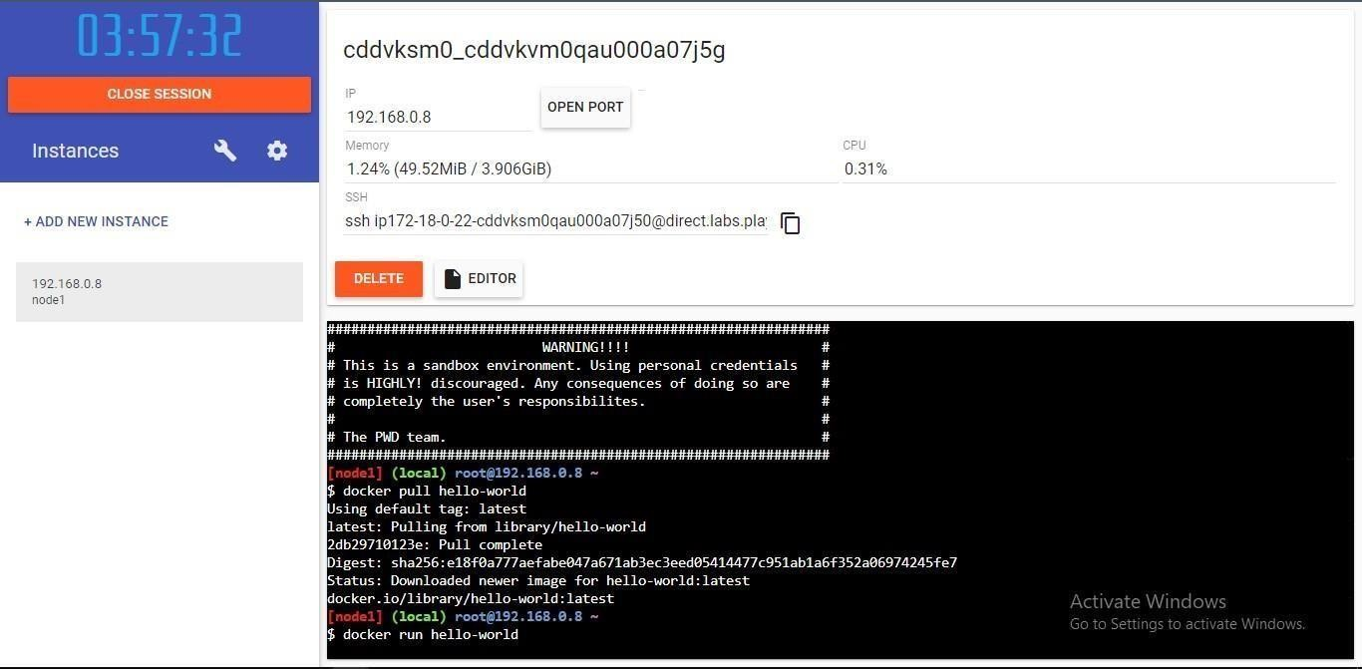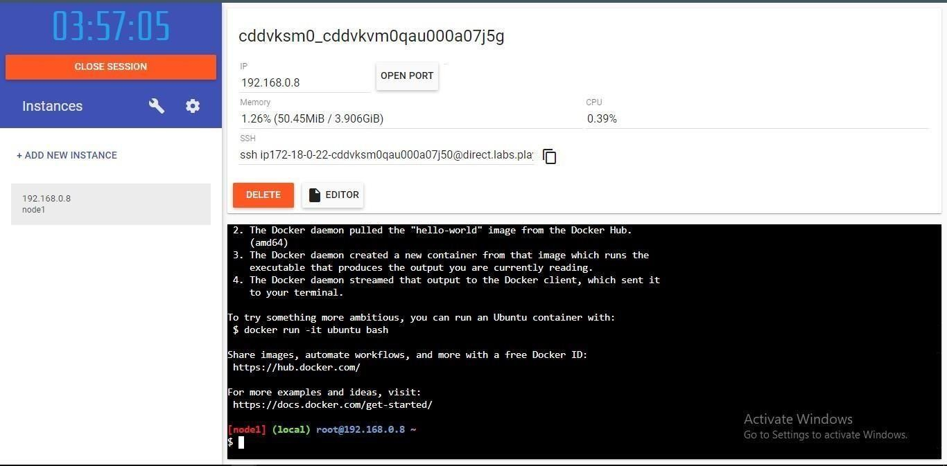

1. Createadockerﬁleforthejobportalapplicationand deployitinDockerdesktopapplication.

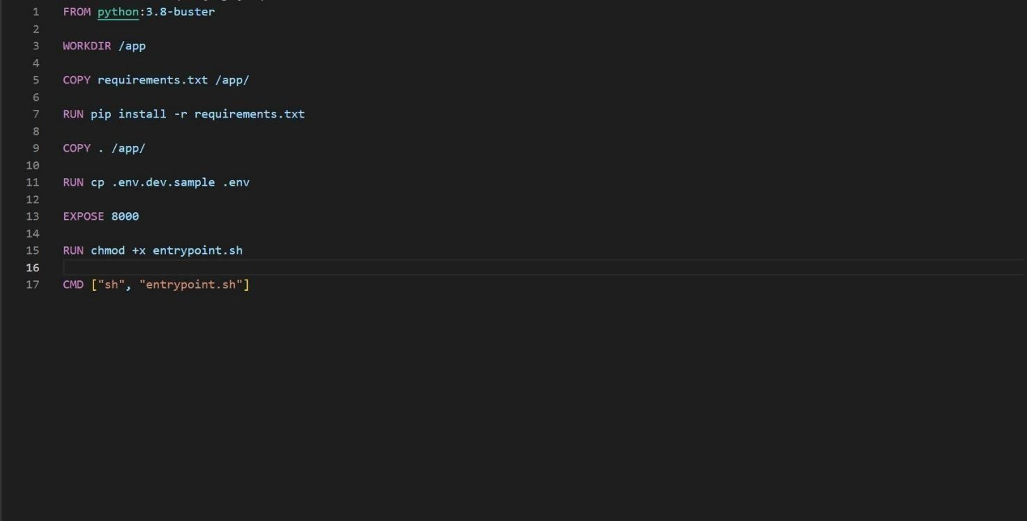

DOCKERFILE

DEPLOYMENTOFJOBPORTALAPPLICATION:

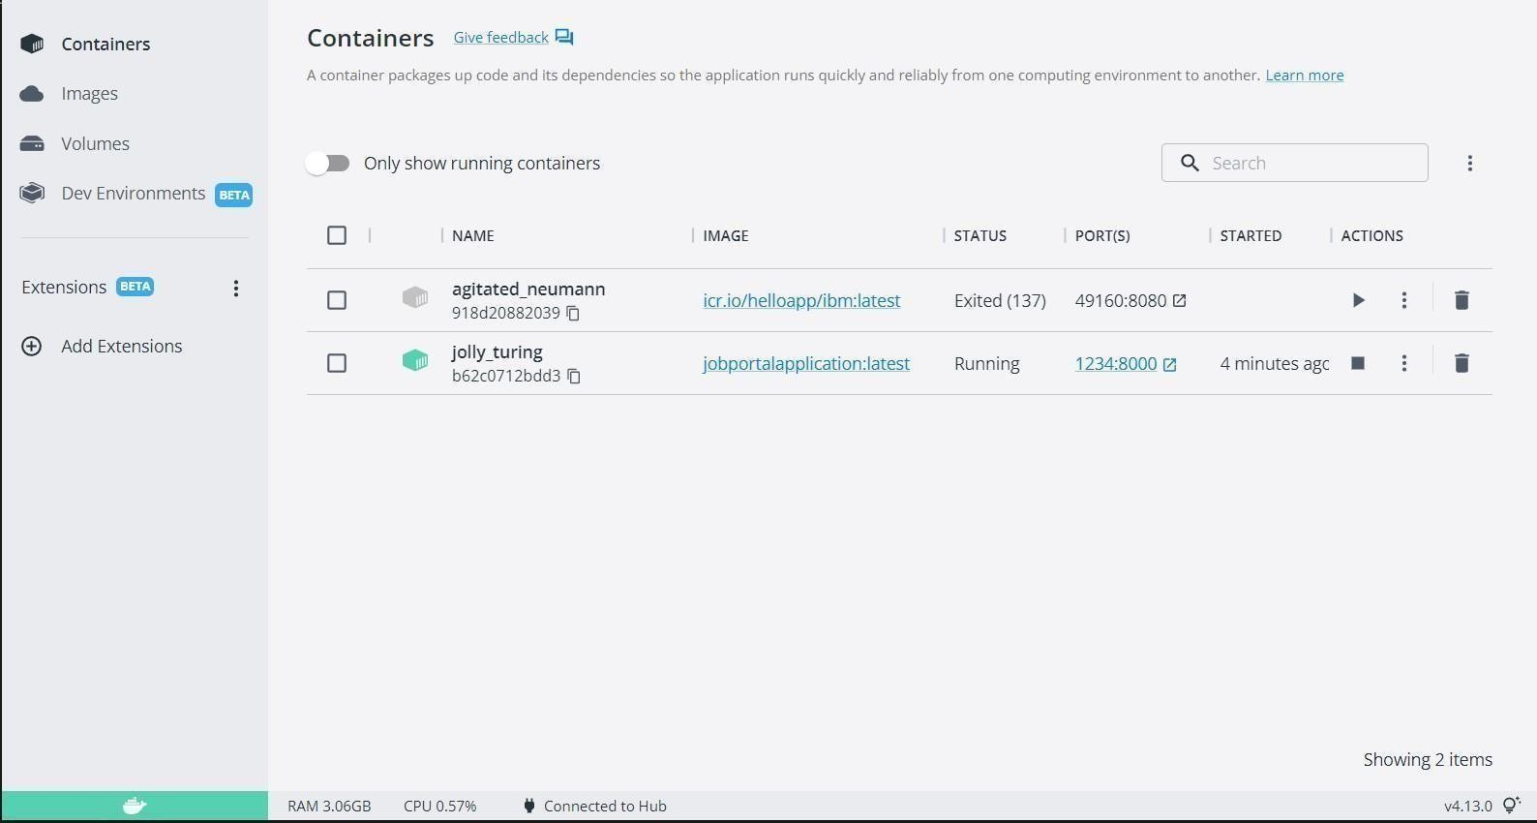

1. CreateaIBMcontainerregistryanddeployhelloworldapp.IBMCONTAINERREGISTRYDEPLOYMENT:

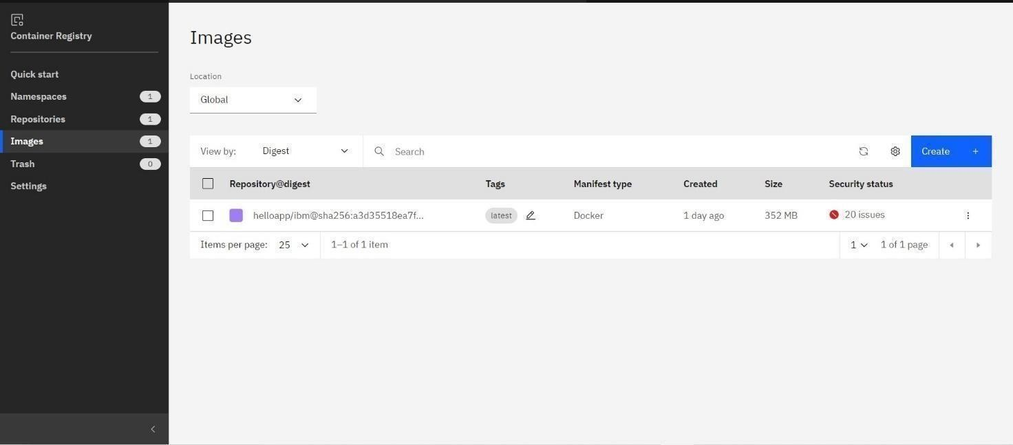

OUTPUT:



1. CreateaKubernetesclusterinIBMcloudanddeployhelloworldimageorjobportalimageandalso expose thesameapp torun in nodeport.

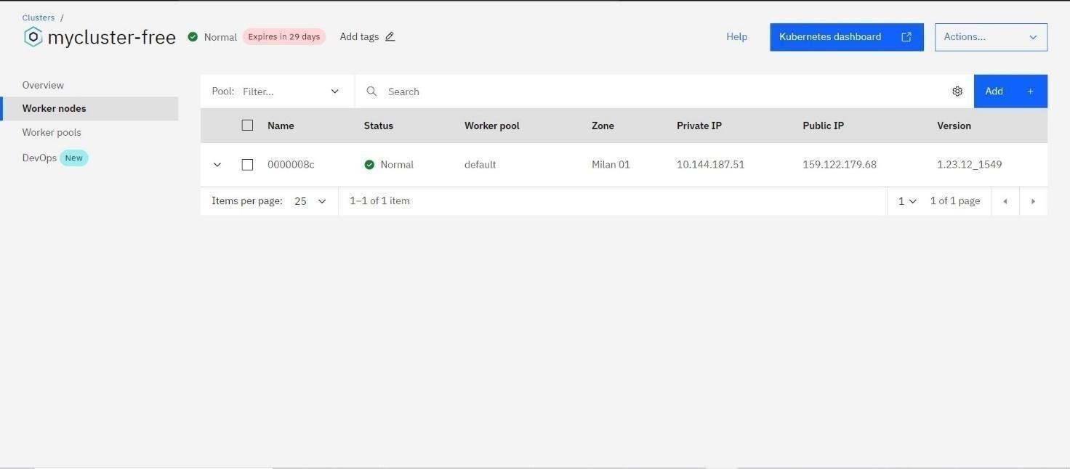CreatingkubernetesclusterinIBMcloudandexposingnodeport: